Project Features: Digital Input and Digital Output.

Program an Arduino board to accept a 4-bit binary input and display the numerical value (0 to 9) on a 7-Segment LED display.

Use the pushbutton for the digital input:

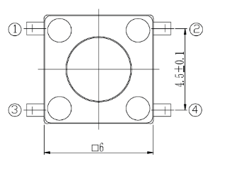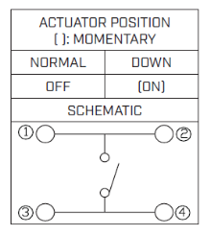
Use the 7-Segment LED Display:
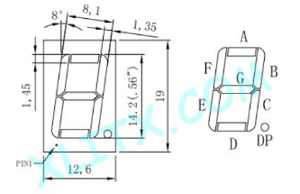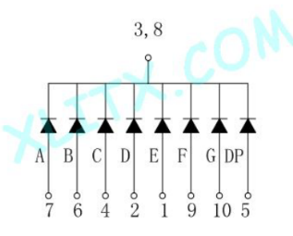
Pin 1
Pin 5
Pin 10
Pin 6

To document your program, create a document and include the following sections in the document. Provide a brief description of the system and how you are designing it to operate,

A. Hardware Diagram:
Provide a hardware diagram of the components.

Analog Input
13
12
~ 11
~ 10
~ 9
8
7
~ 6
~ 5
4
~ 3
2
TX 1
RX 0
3.3V
5V
Gnd
Gnd
Vin
A0
A1
A2
A3
A4
A5
Power
Digital Input / Output
Arduino UNO
Hardware Diagram

B. Program Flowchart:
Draw a flowchart of the program using the Word graphics shapes.
Read Binary Input
Setup Input and
Output Pins
Y
Y
Y
Y
Y
Y
Y
Y
Y
Display “9”
Display “8”
Display “7”
Display “6”
Display “5”
Display “4”
Display “3”
Display “2”
Display “1”
Y
Display “0”
N
N
N
N
N
N
N
N
If 1001
If 1000
If 0111
If 0110
If 0101
If 0100
If 0011
If 0010
N
N
If 0001
If 0000
Display Blank
C. Arduino Source Code
// Hardware Project 2 - 7-Segment Display with 4-bit Binary Input

void setup()
{
// Setup 7-segment display output pins
pinMode(13, OUTPUT); // segment g
pinMode(12, OUTPUT); // segment f
pinMode(11, OUTPUT); // segment e
pinMode(10, OUTPUT); // segment d
pinMode(9, OUTPUT); // segment c
pinMode(8, OUTPUT); // segment b
pinMode(7, OUTPUT); // segment a

// Setup binary input pins
pinMode(5, INPUT); // bit 3
pinMode(4, INPUT); // bit 2
pinMode(3, INPUT); // bit 1
pinMode(2, INPUT); // bit 0
}

void loop()
{
// Read the 4-bit binary input and convert to decimal
int number = (digitalRead(5) << 3) | (digitalRead(4) << 2) | (digitalRead(3) << 1) | digitalRead(2);

// Display the corresponding number on the 7-segment display
if (number == 0)
{ digitalWrite(13, LOW); digitalWrite(12, HIGH); digitalWrite(11, HIGH); digitalWrite(10, HIGH);
digitalWrite(9, HIGH); digitalWrite(8, HIGH); digitalWrite(7, HIGH); }

else if (number == 1)
{ digitalWrite(13, LOW); digitalWrite(12, LOW); digitalWrite(11, LOW); digitalWrite(10, LOW);
digitalWrite(9, HIGH); digitalWrite(8, HIGH); digitalWrite(7, LOW); }

else if (number == 2)
{ digitalWrite(13, HIGH); digitalWrite(12, LOW); digitalWrite(11, HIGH); digitalWrite(10, HIGH);
digitalWrite(9, LOW); digitalWrite(8, HIGH); digitalWrite(7, HIGH); }

else if (number == 3)
{ digitalWrite(13, HIGH); digitalWrite(12, LOW); digitalWrite(11, LOW); digitalWrite(10, HIGH);
digitalWrite(9, HIGH); digitalWrite(8, HIGH); digitalWrite(7, HIGH); }

else if (number == 4)
{ digitalWrite(13, HIGH); digitalWrite(12, HIGH); digitalWrite(11, LOW); digitalWrite(10, LOW);
digitalWrite(9, HIGH); digitalWrite(8, HIGH); digitalWrite(7, LOW); }

else if (number == 5)
{ digitalWrite(13, HIGH); digitalWrite(12, HIGH); digitalWrite(11, LOW); digitalWrite(10, HIGH);
digitalWrite(9, HIGH); digitalWrite(8, LOW); digitalWrite(7, HIGH); }

else if (number == 6)
{ digitalWrite(13, HIGH); digitalWrite(12, HIGH); digitalWrite(11, HIGH); digitalWrite(10, HIGH);
digitalWrite(9, HIGH); digitalWrite(8, LOW); digitalWrite(7, HIGH); }

else if (number == 7)
{ digitalWrite(13, LOW); digitalWrite(12, LOW); digitalWrite(11, LOW); digitalWrite(10, LOW);
digitalWrite(9, HIGH); digitalWrite(8, HIGH); digitalWrite(7, HIGH); }

else if (number == 8)
{ digitalWrite(13, HIGH); digitalWrite(12, HIGH); digitalWrite(11, HIGH); digitalWrite(10, HIGH);
digitalWrite(9, HIGH); digitalWrite(8, HIGH); digitalWrite(7, HIGH); }

else if (number == 9)
{ digitalWrite(13, HIGH); digitalWrite(12, HIGH); digitalWrite(11, LOW); digitalWrite(10, HIGH);
digitalWrite(9, HIGH); digitalWrite(8, HIGH); digitalWrite(7, HIGH); }

else
{ digitalWrite(13, LOW); digitalWrite(12, LOW); digitalWrite(11, LOW); digitalWrite(10, LOW);
digitalWrite(9, LOW); digitalWrite(8, LOW); digitalWrite(7, LOW); }
}

D. Demonstration Video
Record and upload a video demonstrating the operation of the circuit. (DONE)

Save the document as a PDF file and submit the PDF document to Blackboard.

